Product Analyst Assignment

(*Take-Home Exercise*)

1. **Being a product Analyst, the few thing I will improve in “Nojoto App”.**

* **Profile:** As of now Nojoto is providing people to showcase their skill.   
  I will make the profile page more professional. I will add a few more columns like Youtube, Gportfolio etc. This will make it easy for users   
  to reach out to Nojoto.  
  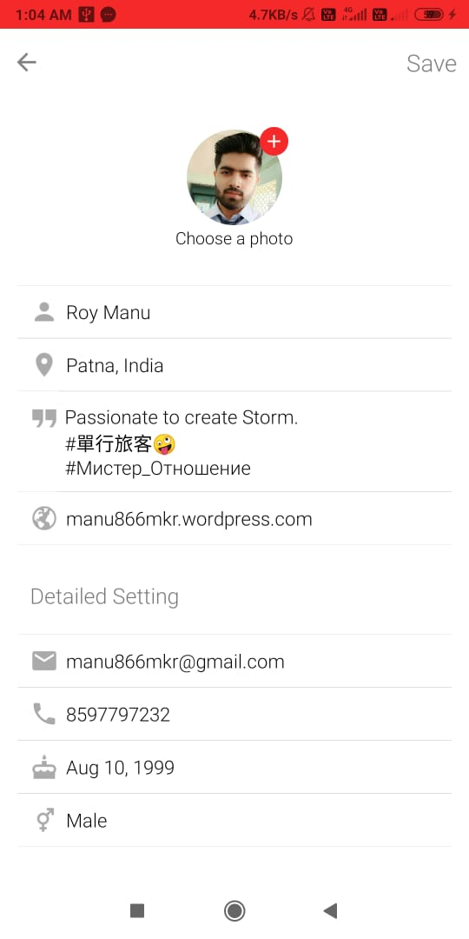
* **AI Audio Filtering:** Most of the users don’t have a specific mic for recording.They use mobile phones/earphones which include **“Noisy Audio”.** We will add a feature **“AI Recording**: It will auto recognise   
  the speech and auto-filter the audio.**” .**It will make us popular among other platforms.

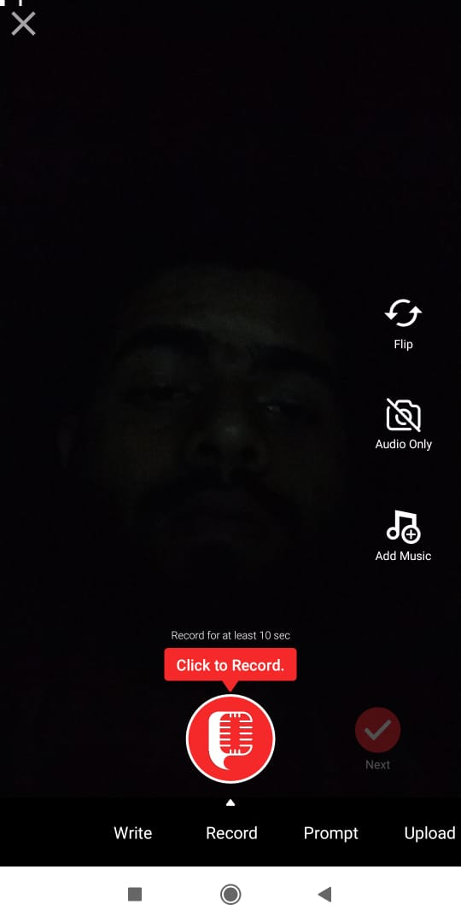

* **AWARD/CERTIFICATION:** We will show the user performace statistics curve to their respective profile. Along with it, We will provide certificates to them for their proficiency in their skill. It will encourage them to be better and create good contents.  
  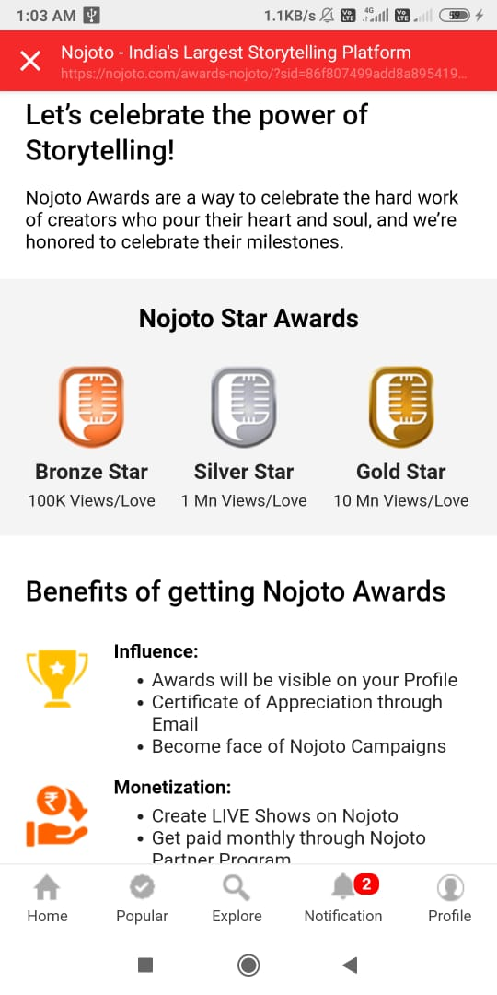
* **Message Box:**  We will add “Message Box” with options “**ON/OFF**”   
  with **restrictions**. Users can on or off it as per their ease.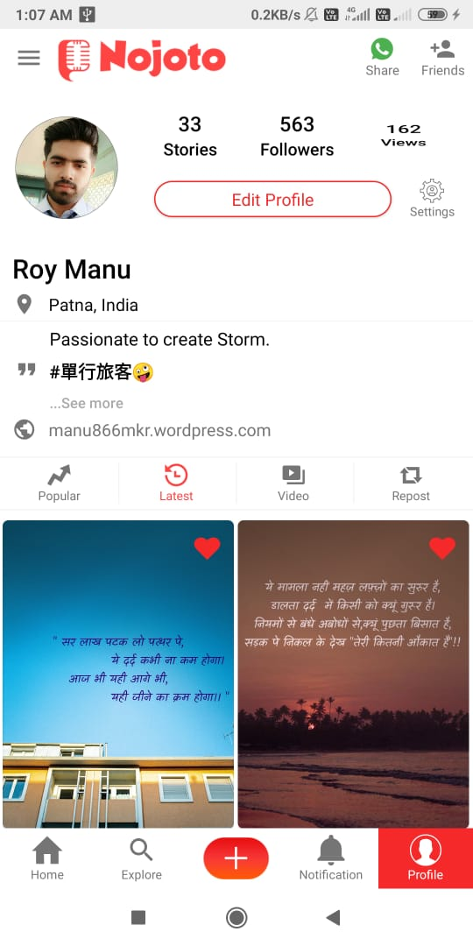

[ ***ON****: His following/follower can message &* ***OFF****: No one can message.*]